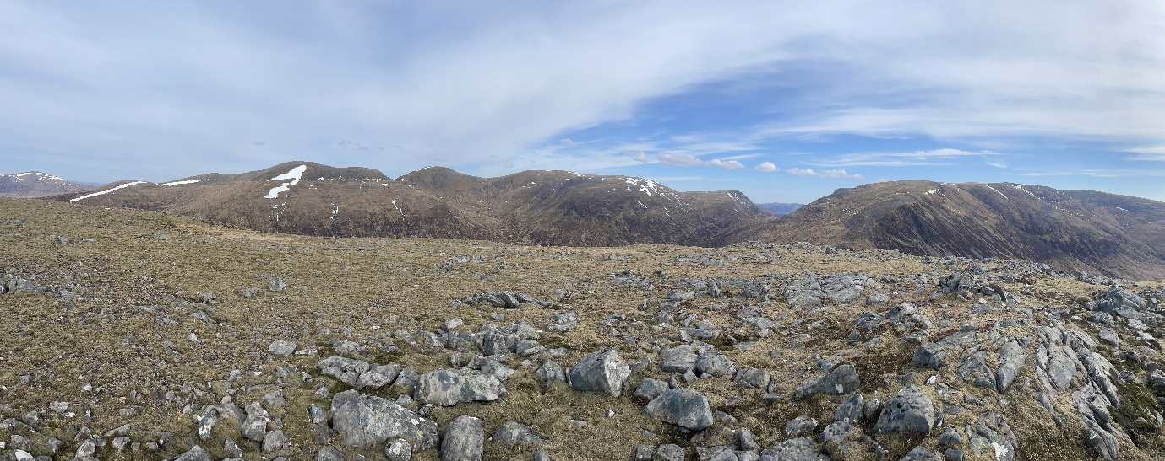
PhD outline: Montane mosaics in Scotland: understanding the past to inform the future
Supervisors: Althea Davies, Katy Roucoux, Dmitri Mauquoy (Univ. Aberdeen)
Partners: Shaila Rao (Conservation Manager, National Trust for Scotland Mar Lodge), Sarah Watts (Corrour Conservation Manager), Charlie Davis (Corrour)
Context and aims: High altitude ecosystems are at the frontline of climate change, yet the capacity of some communities to adapt to changing conditions remains poorly understood. In Scotland, there is particular uncertainty over the role of montane woodland in these ecosystems. On one hand, they are very scarce, and this is thought to be a result of past depletion owing to grazing impacts [1]. Contrasts are often drawn with extensive montane woodland in Norway, to the extent that montane woodlands are considered by conservation proponents to be a ‘missing ecotone’ in Scotland (https://www.msag.org.uk/). On the other hand, with extensive reductions in grazing pressure in numerous areas, climate warming may promote upward expansion of trees like birch, thus placing added pressure on the ability of arctic-alpines to survive in shrinking climate space.
There are calls for more flexible responses to conservation designations to address the uncertainties facing montane ecosystems [2], including a more active approach to restoration of montane woodland [3]. However, active restoration of high-altitude trees is currently resisted by conservation agencies based on an absence of evidence that these once existed, rather than robust evidence that they were absent [4]. This lack of long-term ecological evidence on the form and fate of montane woods and their role in high altitude communities constrains our understanding of how to mediate the tension between proactive measures for montane woods at a time when (sub)arctic-alpine communities are also facing stress. The aim of this project is to examine the long-term ecological evidence for a varied treeline mosaic in the Scottish Highlands and to develop a model of montane woodland and arctic-alpine dynamics to inform conservation. By applying a joint palaeoecological-biogeographical approach, this research will provide a better understanding of the long-term interactions between high altitude trees and shrubs, open arctic-alpine and peat communities, and of their sensitivity to perturbations and dynamics, to inform landscape-scale ecological restoration and conservation planning in Scotland.
Methodology: History does not provide direct analogues for the future, but it can provide evidence for the range of variability in community richness and sensitivity to change. These include the likely effects of more extreme climate/weather events and understanding time lags in biotic responses to climate change. Long-term data can also address a key gap in current knowledge: whether trees were once more extensive in the Scottish montane zone, and, if so, when and how they have been all but lost. This knowledge can be used to validate predictive models and inform restoration planning, particularly the difficult decisions about whether to resist, assist or direct ecological change. Palaeoecology provides the best source of such long-term evidence, spanning decades to millennia, but working at and above the treeline is challenging: pollen can be blown in from lower altitudes and may not represent local tree growth, and pollen productivity in exposed conditions may be low [5]. To address these issues, this project will combine palaeoecological and biogeographical approaches to achieve the following objectives:
- Calibrate palaeoecological records against ecological evidence by analysing short peat cores spanning surface sediments and the recent past in areas with montane tree/shrub growth. This will involve a multiproxy approach, combining pollen and plant macrofossils since the latter are locally deposited.
- Characterise montane scrub refugia by analysing and mapping the microclimate of extant arctic-alpine communities with tree/shrub growth to assess whether there is consistency or high variability (i.e. chance, probable survival in suboptimal conditions) [6]. This will involve producing new microclimate measurements and making use of secondary data. It aligns well with future-oriented ‘opportunity mapping’ for montane woods [1].
- Select sites for Holocene palaeoecological analysis of montane dynamics (pollen, plant macrofossils, charcoal, fungal spores) informed by microclimate mapping (objective 2) and interpret the records using the modern calibration (objective 1) and by adapting interpretative models developed in Norway [7].
This methodology allows the project to advance our understanding of montane vegetation dynamics by examining whether Norway provides a suitable model for Scotland’s montane future, or whether Scotland has a unique montane ecosystem, owing to historical contingencies and ecological distinctions. A successful candidate can explore the potential for using additional proxies (e.g. lipid biomarkers, macrocharcoal spectroscopy), depending on skills and additional funding. This work will take place in three areas of the Scottish Highlands with an active interest in conserving and expanding montane communities: Mar Lodge, Corrour and Ben Lawers. The ecologists working there have proactively sought research evidence on the history of mountain woodlands.
Supervision and training: The supervisory team provides expertise in conservation palaeoecology, science communication and palaeoclimate research. Prior experience of either palaeoecology or ecology is preferred, and the student will be provided with methods training and support in St Andrews (pollen, microclimate modelling) and Aberdeen (plant macrofossils). Project partners will provide insight into current management efforts and challenges in the montane zone. The student would have (bi)monthly hybrid meetings with all supervisors and partners to ensure collaboration across research and practice. SGSD and institutional GradSkills training provide a welcoming environment to develop transferable skills (e.g. data visualisation), while the Environmental Change Research Group offers a vibrant peer network and exposure to international seminar speakers. This PhD represents an opportunity for collaborative training that will equip a successful student for a career in global change ecology and conservation, and allow the candidate to strengthen the research-practitioner networks that are needed to support environmental management in the Anthropocene.
References: [1] Watts. 2024. Restoration Ecology e14290. https://doi.org/10.1111/rec.14290; [2] Trivedi et al. 2008. Biological Conservation 141:1665-75; [3] Watts & Jump. 2022. Restoration Ecology 30:e13701; [4] Tipping. 1997, pp. 11-19 in Gilbert et al. (eds.). The ecology and restoration of montane and subalpine scrub habitats in Scotland. Scottish Natural Heritage, Edinburgh; [5] Nagy et al. 2013. Plant Ecology & Diversity 6:7-19; [6] Maclean et al. 2019. Methods in Ecology and Evolution 10:280-90; [7] Birks & Bjune. 2010. Vegetation History and Archaeobotany 19:325-40.

